Rotary Club of Kathmandu Mid-Town
Breakfast Chatter




14 October 2011 The Weekly Bulletin of Rotary Club of Kathmandu Mid-Town Bc-10.14/011-12

District: 3292 Web: www.rotarymidtown.org.np Club Id : 26776

OCTOBER IS THE VOCATIONAL SERVICE MONTH
Vocational Service is the way Rotary fosters and supports the application of the ideal of service in the pursuit of all vocations. Inherent in the Vocational Service ideal are:
1) Adherence to and promotion of the highest ethical standards in all occupations, including faithfulness and fidelity to employers, employees, and associates, and fair treatment of them and of competitors, the public, and all those with whom one has any business or professional relationships;
2) The recognition of the worthiness to society of all useful occupations, not just one’s own or those which are pursued by Rotarians;
3) The contribution of one’s vocational talents to the problems and needs of society.

Friday, 7 October:
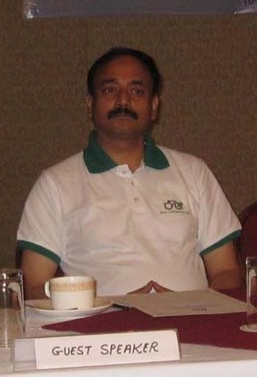
Mr Paras SJB Rana, General Manager, Hotel de l’Annapurna, while presenting a very interesting talk on ‘Greening Your Hotel’ emphasized on three slogans – ‘Be Green’, ‘Go Green’, and ‘Do Green’. We must focus on these slogans on any thing we do to save our planet Earth for next generations.
He suggests 10 ways to go greening hotels – unplugging power when not in use, economizing water consumption, using compact lights, avoiding packaging, going for organic foods, less driving/more walking, planting trees, recycling wastes, using green power and promoting green to staff as well as to guests.
He informed that his Hotel already practice some of the steps such as discouraging plastic use, rain water harvesting, using recycled papers, using electric vehicles, encouraging staff to commute in cycle etc.

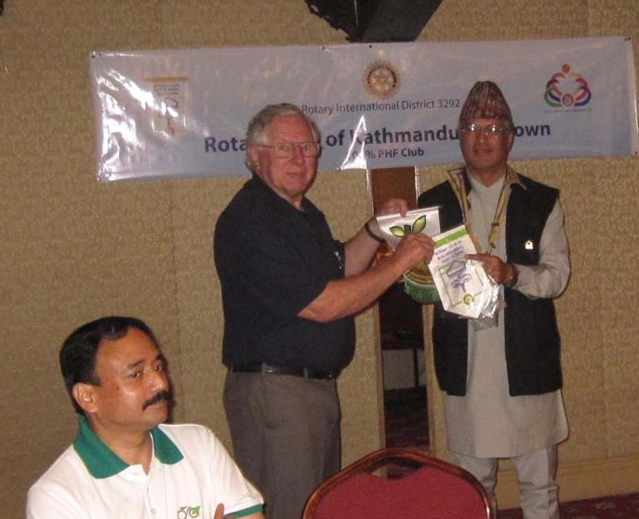

President Som accepting club banners of Rotary Clubs of Castle Hill Inc/Terrugal, Australia
and providing RC Kathmandu Mid-Town banner to Rtn Ron Marcus.

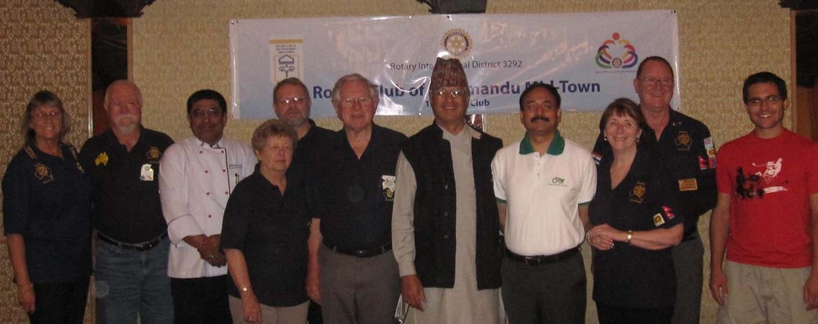
Group photo with guest Rotarians/spouses from Rotary Club of Castle Hill Inc /
Rotary Australia World Community Service who attended the Club meeting.

Weekly Meetings and Programs :
Date | Program/Speaker | Program/Topics of Presentation
14 October 2011 | Dr Buddha Basnet | Travel and mountain medicines
21 October 2011 | Rtn Kul C Gautam | On Rotary regional conference in SriLanka 4 Sep 011
28 October 2011 | Holiday | No meeting
4 November 2011

Dashain Special Recital
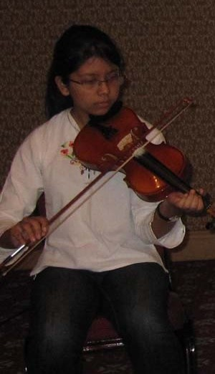

On 7 Oct Friday morning during the meeting Miss Pallavi Shrestha, daughter of Rtn Dr Rabindra, presented an enchanting Raga Malsree recital with her Violin on the occasion of Dashain festival. Raga Malsree recital is popular during Dasain. The recital was enjoyed by all present. President Som wished all the best to the young musician, recognized it as one more example of family participation in Club fellowship and presented a token of appreciation to her too.
Club members, if you have somebody near and dear one having expertise/talents on any field and if you wish to provide them opportunity for presentation of their skill/expertise/talent and fellowship in the Club, please contact President Som or Secretary Amar. This will be a great opportunity for them too to present their talents and develop confidence.

RI Convention 2012, Bangkok:
Register now for the 2012 RI Convention in Bangkok, Thailand, 6-9 May, and enjoy an unforgettable experience in the Land of a Thousand Smiles!
Enjoy Thai hospitality. Make friends with fellow Rotarians from around the world. Take in spectacular sights. Taste delicious Thai cuisine. Experience a vibrant culture. Renew your commitment to Service Above Self. And have fun in a world class city. .

Rota-Quiz
The zonal level Rota-quiz is scheduled to be held in November 2011 and final in Jan 2012. The Club needs to form Rota-quiz sub-committee as soon as possible if the Club decides to participate in the District program.

District Conference 2012
The 4th District Conference of RI District 3292 is scheduled to be held on 5-7 January 2012 at Birendra Sabha Griha, Biratnagar.
Register on time to avoid increase in registration fee;
Contact Rtn. Binod Agrawal on 9852021130 for room booking and other details.

Public is aware of Rotary, but unsure of what we do

Do your friends and co-workers know that you're a Rotarian? Do you tell acquaintances about your club's good works in the community or internationally?

Did you know that talking about your involvement in Rotary could significantly enhance the organization's image and boost public awareness? It’s up to every Rotarian to tell the world what Rotary is and does.

According to a public image survey commissioned by Rotary International in 2010, people are much more likely to know about Rotary and perceive it positively as a charitable organization if they personally know a Rotarian. The finding is just one of many that could shape how clubs and districts promote Rotary in their communities.

RI commissioned the survey of 1,000 individuals in each of six countries -- Argentina, Australia, Germany, Japan, South Africa, and the United States -- to gauge the general public's awareness and perception of the organization. The results are consistent with those of a similar survey conducted in 2006: While respondents had heard of Rotary, they did not know much about what it does.

Building familiarity is not easy, says Pauline Leung, Rotary public image general coordinator. "Sometimes Rotarians are doing too many things and can get people confused about Rotary. We must have consistency when promoting the image of Rotary. Rotarians should receive training so they can clearly express our position, our vision, our values, and our areas of focus."

(Source: RI News)

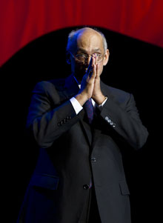
Service does require time, and time is something nobody has enough of these days. So we need to
ensure that all the time we spend with Rotary is worthwhile – that it is rewarding and never wasted.

RI President Kalyan Banerjee

Life with computers:


Please send project/activity information, suggestions and photos etc to :
BC Editor: RR Shrestha email: rryes@wlink.com.np

14 October 2011 The Weekly Bulletin of Rotary Club of Kathmandu Mid-Town bc-10.14/011-12

